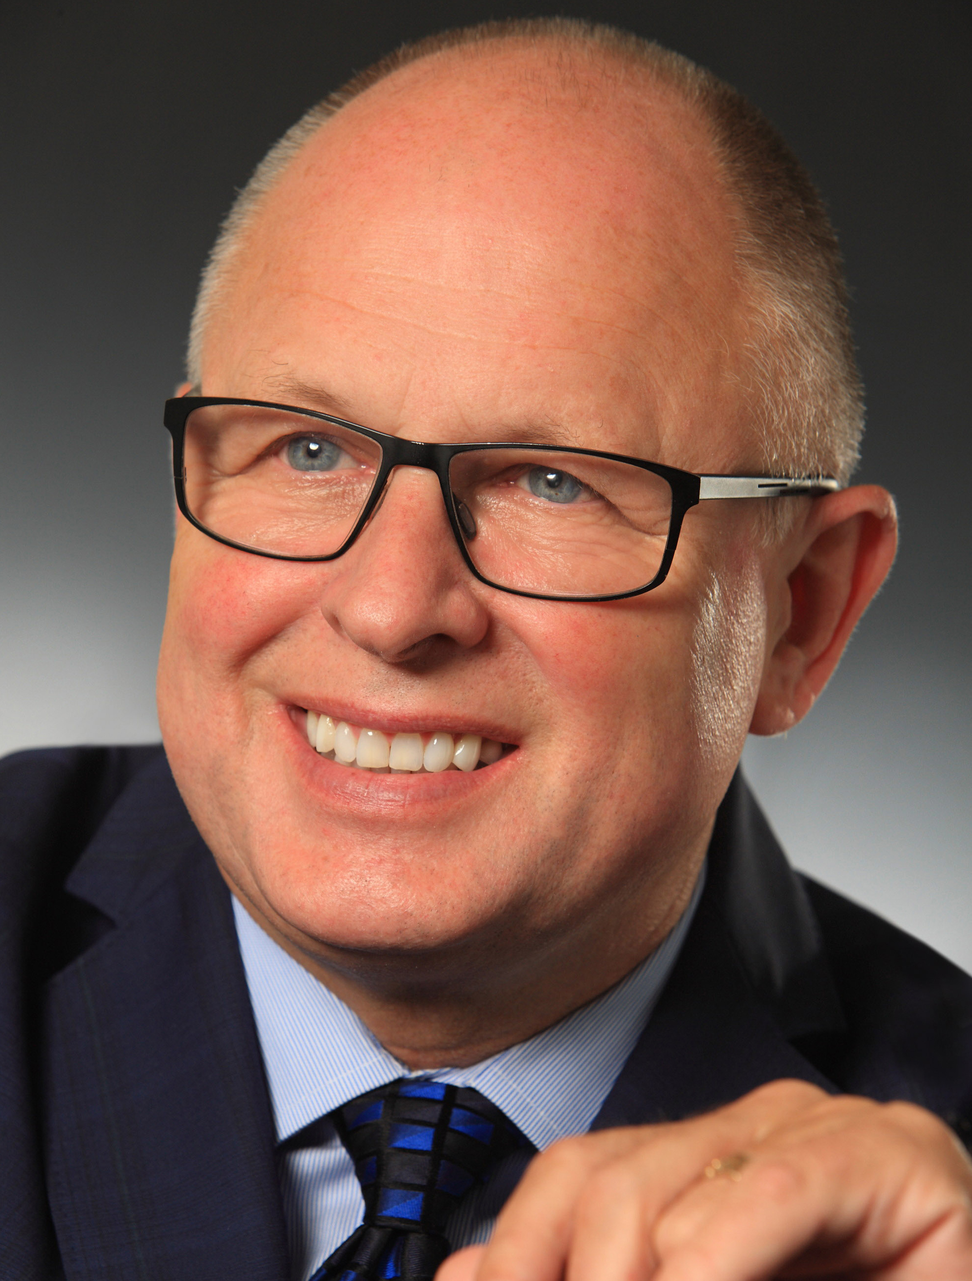

SID RYAN

PRESIDENT, ONTARIO FEDERATION OF LABOUR
Born in Dublin, Republic of Ireland, Sid Ryan is in his second term as the President of the Ontario Federation Labour, Canada’s largest provincial labour federation, where he represents 54 unions and over one million workers. Previously, Sid headed up CUPE Ontario for 17 years and became one of the labour movement’s most recognized voices on public health care, education and public services. His firebrand militancy and unwavering principles have earned him an international reputation as a champion of equity, social justice and human rights.
Since becoming President of the OFL two and a half years ago, Sid has reinvigorated a progressive fighting spirit in the labour movement and mobilized incredible strike support for thousands of workers throughout the province. He has also built new and strong ties with over 90 community groups, environmentalists, ethnic and faith-based organizations and students under the banner of the “Ontario Common Front.” Sid is intensifying the fight against cuts to jobs and public services by mobilizing a province-wide campaign for Democratic and Economic Rights that will bring thousands to Toronto on January 26 to protest the Ontario Liberal Leadership Convention and challenge Ontario’s Austerity Agenda in the upcoming provincial election.

Reach Sid at 416-209-0066 or SRyan@ofl.ca

