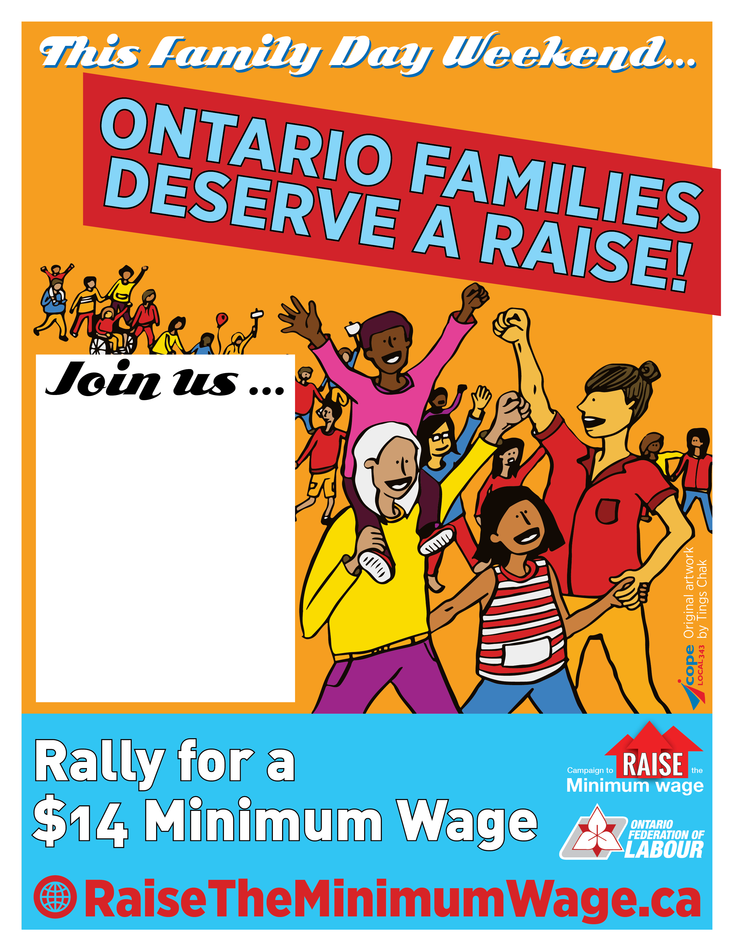
For a [rally/teach-in] at [time] on Saturday, February 15 at [location], [address] [city]

Hosted by [sponsors/organizations]

