RALLY FOR  FAIRNESS | SATURDAY, OCTOBER 5  BONFIELD, ONTARIO
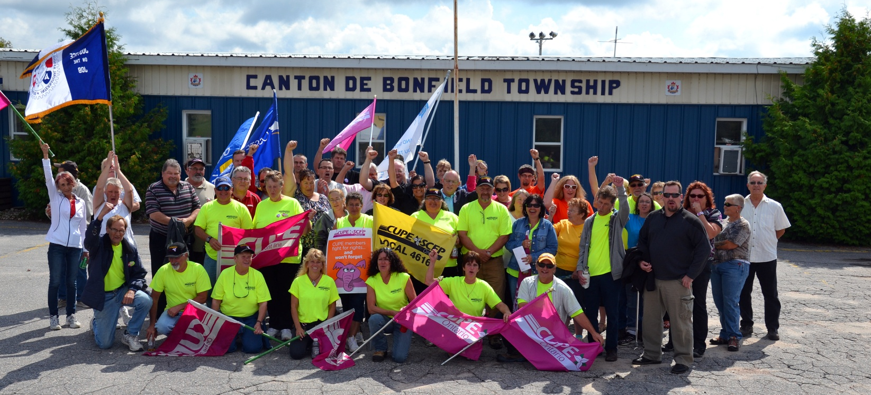
TAKE A STAND AGAINST BULLYING – SOLIDARITY WITH BONFIELD MUNICIPAL WORKERS
Sixteen municipal workers in Bonfield were forced into a defensive strike on August 1.
In September, the mayor fired one-third of the bargaining unit.
Don’t let them get away with bullying workers!
Bonfield Municipal Town Hall
365 Highway 531 (off Hwy 17)
1-3 p.m.
Saturday, October 5

NO CONCESSIONS! NO BULLYING!
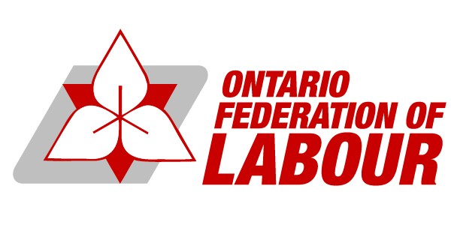
OCTOBER 5 – RALLY FOR FAIRNESS
Public services are important. Take a stand against contracting out and the trend of concessions. Stand up for fairness with CUPE Local 4616.
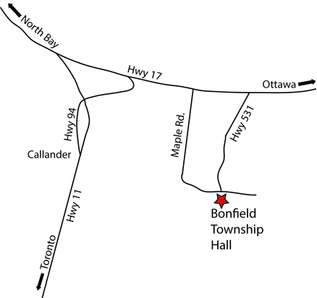
FROM TORONTO:  Take Hwy 400 north through Barrie, then Hwy 11 to Lake Nosbonsing Rd. exit (at Callander). Exit and take first right onto Hwy 94 (Callander Bay Dr.). Follow to Hwy 17 and turn right. Turn right and follow Hwy 531 to a fork in the road and you are there! | FROM OTTAWA:  Take the Trans-Canada Highway (Hwy 17) north to Hwy 531. Turn left onto Hwy 531 and continue south to a fork in the road where you will see the rally!

BUS INFORMATION

For more information and news about the rally and the strike, visit cupe.on.ca
and join the rally event page at www.facebook.com/events/212927145543200/

:gb/cope491

